Kevin Kelsey - A+ Computer Science IFS – Spiral Planting Lab Value - 100

Lab Goal: To analyze a problem and involve branching and decision making in creating a solution for the problem. You must determine how many times to hop, when to turn and most importantly when to stop. You must create commands based on the various requirements of this problem.
Lab Description: This lab requires you to use a wide variety of if commands. Each cycle of the loop should produce movement on only turn at a time. If none of the various conditionals are met, the jeroo should hop twice in the direction it is currently facing. This type of programming involves not only using if but using while also. Failure to use the proper commands will mean your Jeroo will not plant the flowers in the correct pattern.
.
Files Needed:
sprialPlanting.jsc
No island file needed

Starting Screen:


algorithm help

Required Conditionals:
- Water Ahead – Turn Right
- When Clear Ahead – hop and plant

Postcondition:
- Jeroo is not in the water
- Jeroo is facing North
- Jeroo is surrounded by flowers
- Program Ends

Ending Screen:
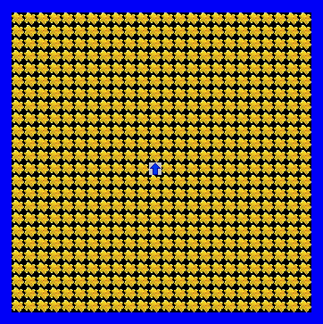

BONUS: Write the loop and ifs as part of a SEPRATE method +1

